# 1.Write a python program to test a given number is prime or not.

# num = int(input("Enter your number:"))

# flag = False

# if num > 1:

# for i in range(2, num):

# if (num % i) == 0:

# flag = True

# break

# if flag:

# print(num, "is not a prime number")

# else:

print(num, "is a prime number")

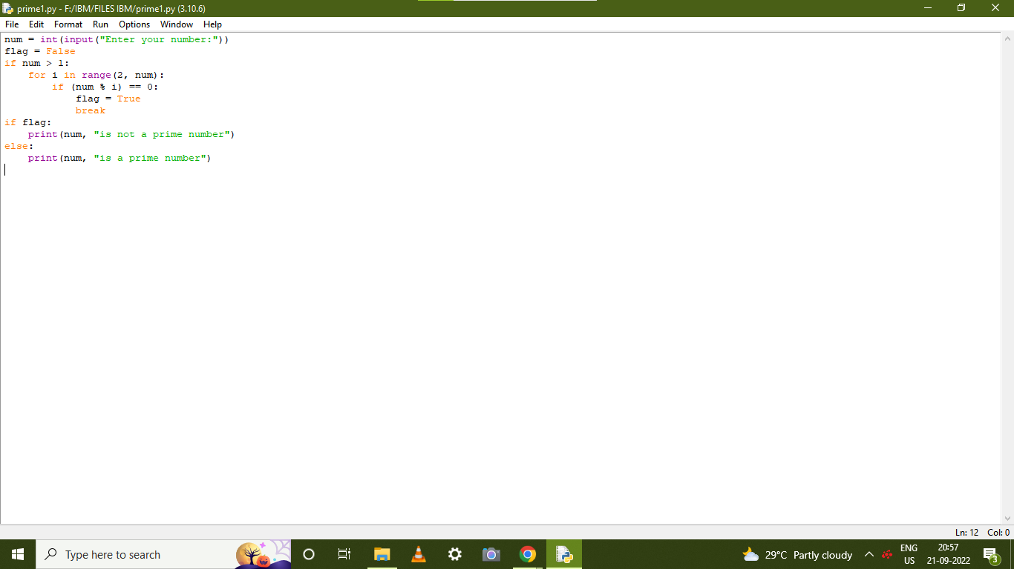

# OUTPUT:

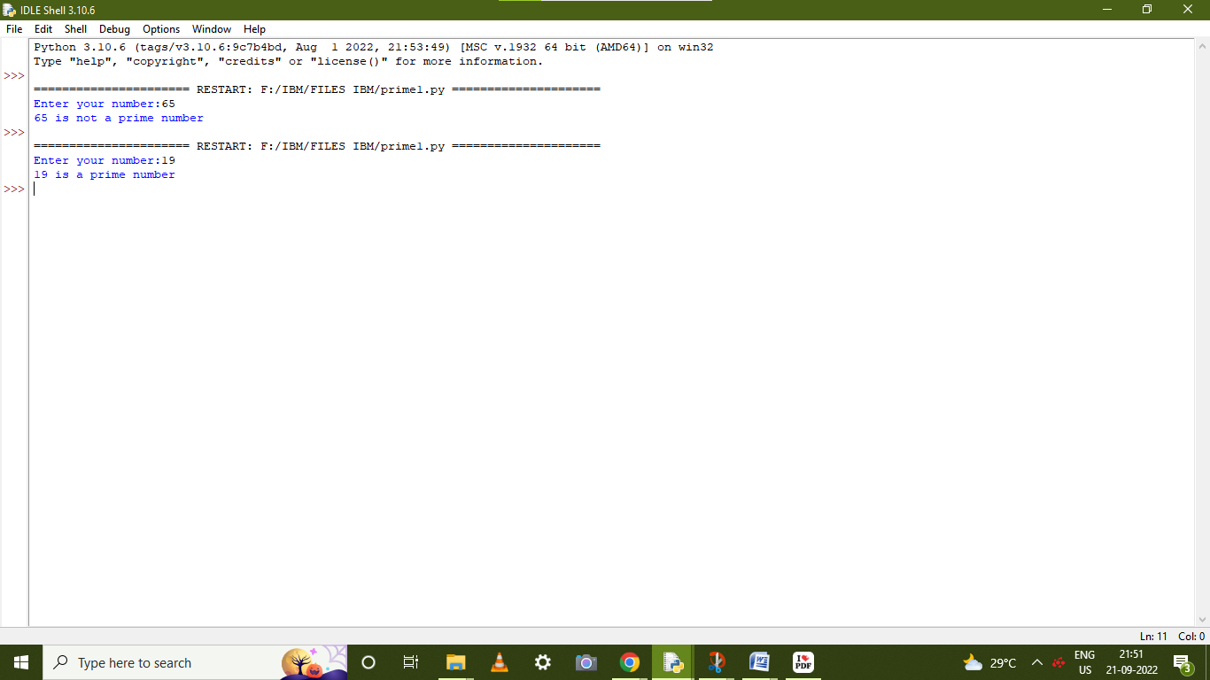

**2.Write a program to generate odd numbers from m to n using while loop.**

**start= int(input(" Please Enter A minimum value:"))**

**end=int(input(" Please Enter B Maximum Value : "))**

**for num in range(start, end + 1):**

**if num % 2 != 0:**

**print(num, end = " ")**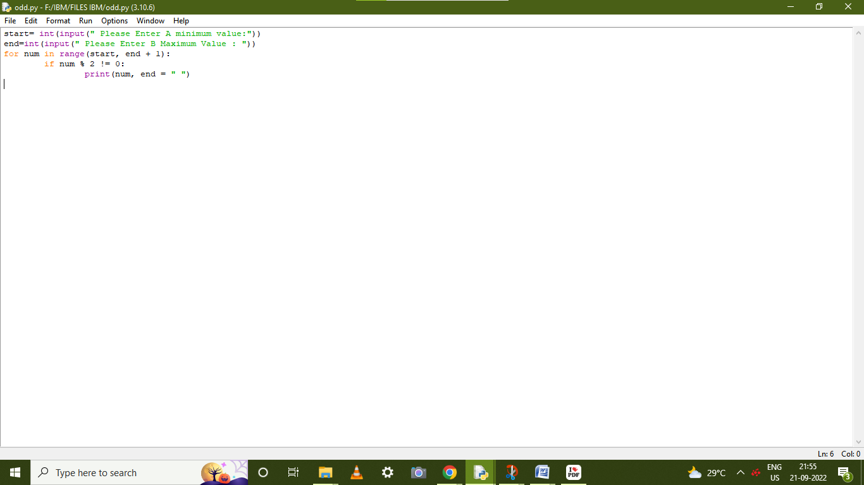

# OUTPUT:

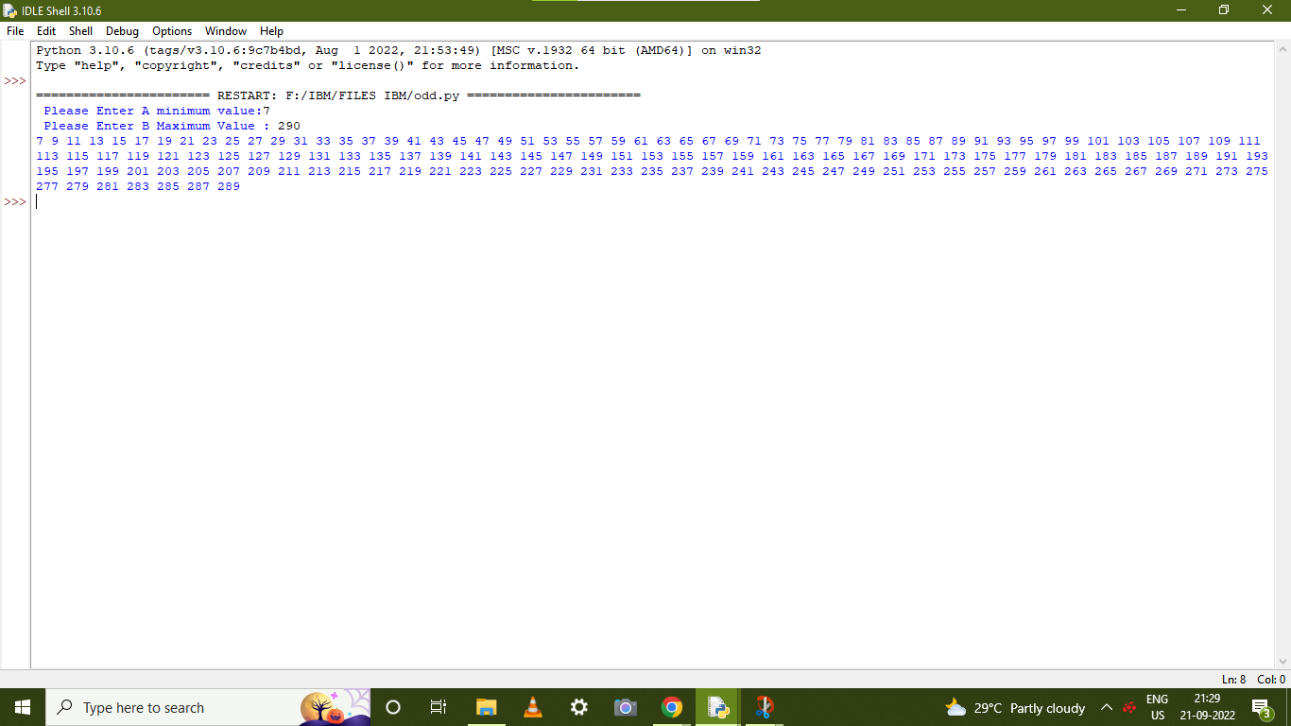

3.Write a python program to display prime number series up to given number.

**lower =int(input(" Please Enter minimum value:"))**

**upper =int(input(" Please Enter maximum value:"))**

**print("Prime numbers between", lower, "and", upper, "are:")**

**for num in range(lower, upper + 1):**

**if num > 1:**

**for i in range(2, num):**

**if (num % i) == 0:**

**break**

**else:**

**print(num)**

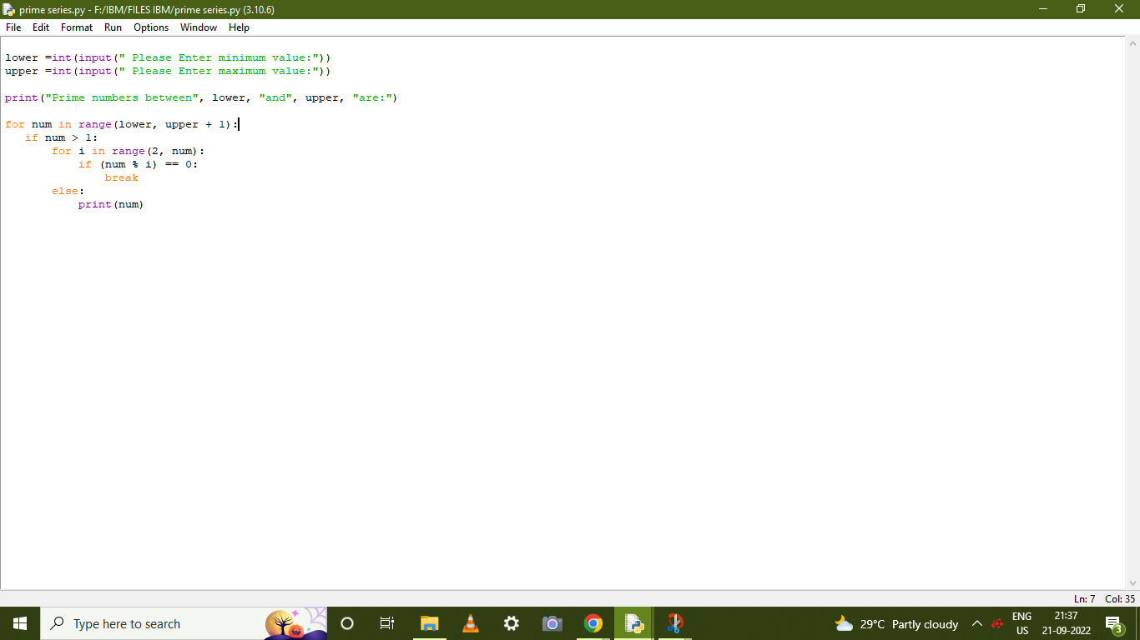

**OUTPUT:**

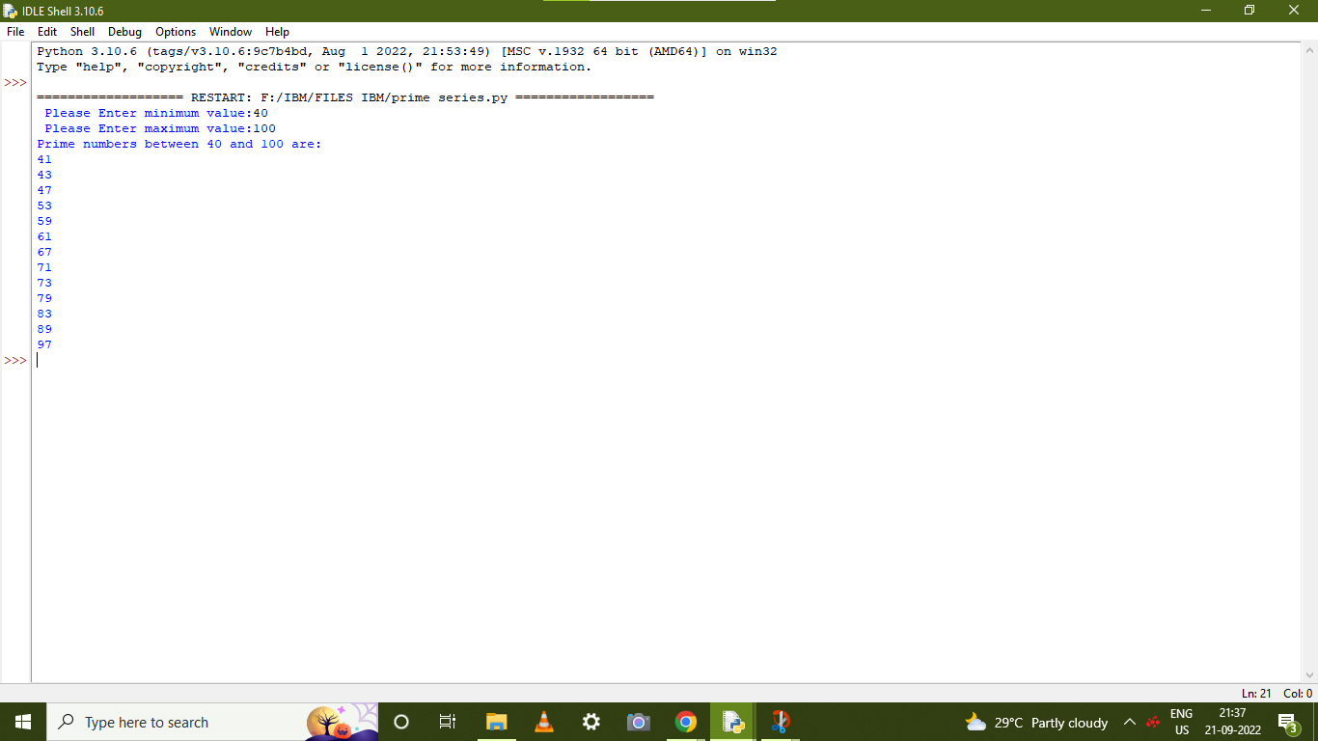

# 4.Write a python program to generate Fibonacci series

num = int(input ("How many terms want to print? ")) num1= 0

num2= 1

count = 0

if num <= 0:

print ("The given no is not valid,please enter +ve integer") elif num == 1:

print ("The Fibonacci sequence of the numbers up to", num, ": ") print(num1)

else:

print ("The fibonacci sequence of the no is:") while count < num:

print(num1)

nth = num1 + num2 num1= num2 num2= nth

count += 1

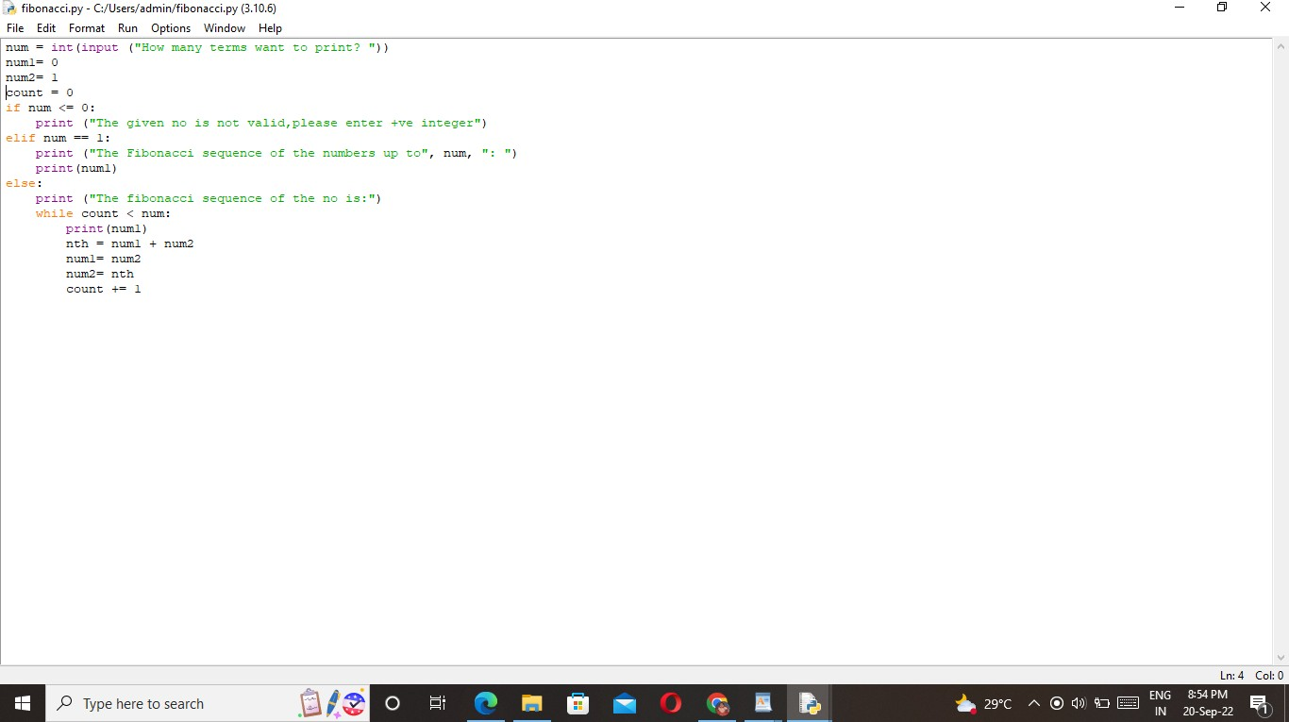

# OUTPUT:

